**FITFLEX: YOUR PERSONAL COMPANION (REACT APPLICATION)**

.

**TABLE OF CONTENTS**

Chapter Title Page no

1. **Acknowledgement**
2. **Synopsis**
3. **Introduction**
4. **Analysis of the Problem**
   * System Analysis
   * Existing System
   * Limitations of Existing System
   * Proposed System
5. **Feasibility Study**
6. **Analysis Tools**
   * Functional Diagram
   * Dataflow Diagram
   * Entity Relationship Diagram
   * Hardware/Software Configuration
7. **System Design**
   * Input Design
   * Output Design
   * Software Specifications
8. **Testing and Maintenance**
9. **Conclusion**
10. **Appendix**
    * Screenshots
    * Tables
    * Codings
    * Reports
11. **Bibliography**

## Acknowledgement

We would like to express our gratitude to everyone who contributed to the development of **FitFlex: Your Personal Companion**. Our deepest thanks to the instructors, mentors, and all those who offered their expertise in fitness, software development, and UI/UX design.

We also acknowledge the resources and documentation provided by libraries and frameworks such as React, Firebase, and Material-UI, which helped us create an intuitive and user-friendly interface.

**Synopsis**

**FitFlex: Your Personal Companion** is a revolutionary fitness application that transforms your workout experience. With an intuitive interface, dynamic search functionality, and a vast library of exercises suited for all fitness levels, FitFlex allows users to embark on a personalized fitness journey. It provides users with the tools to track their progress, set fitness goals, and maintain motivation throughout their wellness journey.

This app is aimed at people who are interested in achieving their wellness goals in an easy and efficient way, whether they are beginners or seasoned fitness enthusiasts.

**Introduction**

**FitFlex** is a dynamic, feature-packed fitness application designed for users of all fitness levels. It combines a broad array of fitness tools, from exercise libraries to workout tracking and progress monitoring, to assist users in achieving their wellness goals. FitFlex provides personalized recommendations based on the user’s preferences, helping them stay motivated and on track throughout their fitness journey.

The app leverages a user-friendly interface and provides the option for users to integrate their data with fitness wearables like Fitbit and Apple Watch to create a holistic fitness experience. It is designed for mobile and desktop users, ensuring that users can access their fitness data anytime, anywhere.

## Analysis of the Problem

### System Analysis

The current state of fitness applications lacks personalization and is often overwhelming for users, especially beginners. Many fitness apps present long, complex workout plans without considering the user’s specific goals, preferences, or fitness level. This results in lower user engagement and failure to achieve long-term fitness goals.

FitFlex aims to address this by providing personalized fitness plans, workout tracking, and motivational features in a simple, easy-to-use application. The goal is to offer a more engaging experience and bridge the gap between fitness goals and workout completion.

### Existing System

Most current fitness apps, such as MyFitnessPal, Fitbit, and Nike Training Club, offer basic tracking of workouts, nutrition, and progress. However, they tend to be either too generalized or too focused on niche fitness needs, failing to provide a balanced approach for users at different fitness levels. Additionally, existing apps often lack intuitive interfaces and offer limited interaction or personalization.

### Limitations of Existing System

* **Lack of Personalization**: Existing fitness apps don't offer enough tailored content based on user fitness levels and goals.
* **Complicated Interfaces**: Many apps have complex interfaces that require a steep learning curve.
* **Limited Exercise Libraries**: Some apps provide limited options when it comes to workout variety.
* **Tracking Gaps**: Lack of integration with wearables or external data sources, making it difficult to consolidate progress.

### Proposed System

The **FitFlex** system is designed to overcome the limitations of current fitness applications. Key features of the proposed system include:

* **Personalized Fitness Plans**: Recommendations based on the user’s fitness goals, preferences, and current fitness levels.
* **Dynamic Exercise Library**: A vast library of exercises with detailed instructions and tips.
* **Intuitive Interface**: Easy navigation and seamless user experience.
* **Progress Tracking**: Integrated with fitness wearables for comprehensive data collection.
* **Motivational Content**: Regular fitness tips and reminders to keep users motivated.

## Feasibility Study

### Technical Feasibility

The project is technically feasible, as modern web technologies (React, Firebase, Material-UI) provide a stable platform to develop and deploy the application. Additionally, the integration with wearable devices and tracking progress will be achieved using APIs from fitness tracking platforms such as Fitbit and Apple Health.

### Operational Feasibility

Operationally, the application will be user-friendly and accessible across various devices, including desktops, tablets, and smartphones. By using Firebase for backend services and React for frontend development, we can ensure a scalable solution for users worldwide.

### Economic Feasibility

The initial cost of development is minimal, as open-source technologies (React, Firebase) and free libraries (Material-UI) will be used. The app can generate revenue through premium features, such as advanced workout plans, diet tracking, or exclusive workout content.

## Analysis Tools

### Functional Diagram

The **Functional Diagram** outlines the various features of the FitFlex app, such as user registration, workout logging, and progress tracking. Each feature is connected to the appropriate backend services like Firebase and external APIs for wearable devices.

### Dataflow Diagram

**Dataflow Diagrams (DFD)** represent the flow of data within the FitFlex system, from the user inputting workout data to the system processing and displaying feedback. Key processes include workout logging, progress tracking, and notifications.

## 

Entity Relationship Diagram

The **Entity Relationship Diagram (ERD)** shows the relationships between different data entities in the system, such as users, workouts, exercises, and progress records. This diagram ensures the database structure is efficient and supports the required functionality.

### Hardware/Software Configuration

* **Frontend**: React.js, Material-UI, Chart.js, Firebase
* **Backend**: Firebase (for user authentication and data storage)
* **Devices**: Integration with fitness wearables such as Fitbit, Apple Watch (via their respective APIs)

## System Design

### Input Design

The **Input Design** involves designing how users will interact with the system. This includes forms for user registration, logging workouts, setting goals, and providing feedback on exercises. The inputs will be validated to ensure correct data collection.

### Output Design

The **Output Design** consists of the visual representation of data, such as workout history, progress charts, and daily or weekly summaries. The system will also display recommendations and tips to keep the user motivated.

### Software Specifications

* **Frontend**: React.js (for UI), Material-UI (for styling), Firebase (for data management and authentication)
* **Backend**: Firebase Functions (for handling server-side logic)
* **APIs**: Integration with Fitbit, Apple Health for data collection from wearables

## Testing and Maintenance

### Testing

* **Unit Testing**: Testing individual components (e.g., LoginForm, WorkoutCard).
* **Integration Testing**: Testing interactions between different parts of the app (e.g., user authentication, data storage).
* **Usability Testing**: Ensuring the app is easy to navigate and use.

### Maintenance

* **Bug Fixes**: Periodic updates to fix bugs and improve performance.
* **Feature Updates**: Add new features based on user feedback and market demand.
* **Security Updates**: Regularly update the application’s security protocols to safeguard user data.

## Conclusion

FitFlex is poised to revolutionize the fitness industry by offering a personalized, intuitive, and feature-packed fitness experience. With its unique combination of personalized workout plans, progress tracking, and motivational content, FitFlex helps users achieve their wellness goals efficiently and with ease. The application is technically feasible, user-friendly, and scalable, with future potential for growth through premium features and integrations.

## Appendix

### Screenshots

1. **Login Page**: Screenshot of the login screen showing user authentication options.
2. **Dashboard**: Screenshot showing workout progress, fitness goals, and personalized recommendations.
3. **Workout Log**: Screenshot of the workout logging page, where users can add exercises.

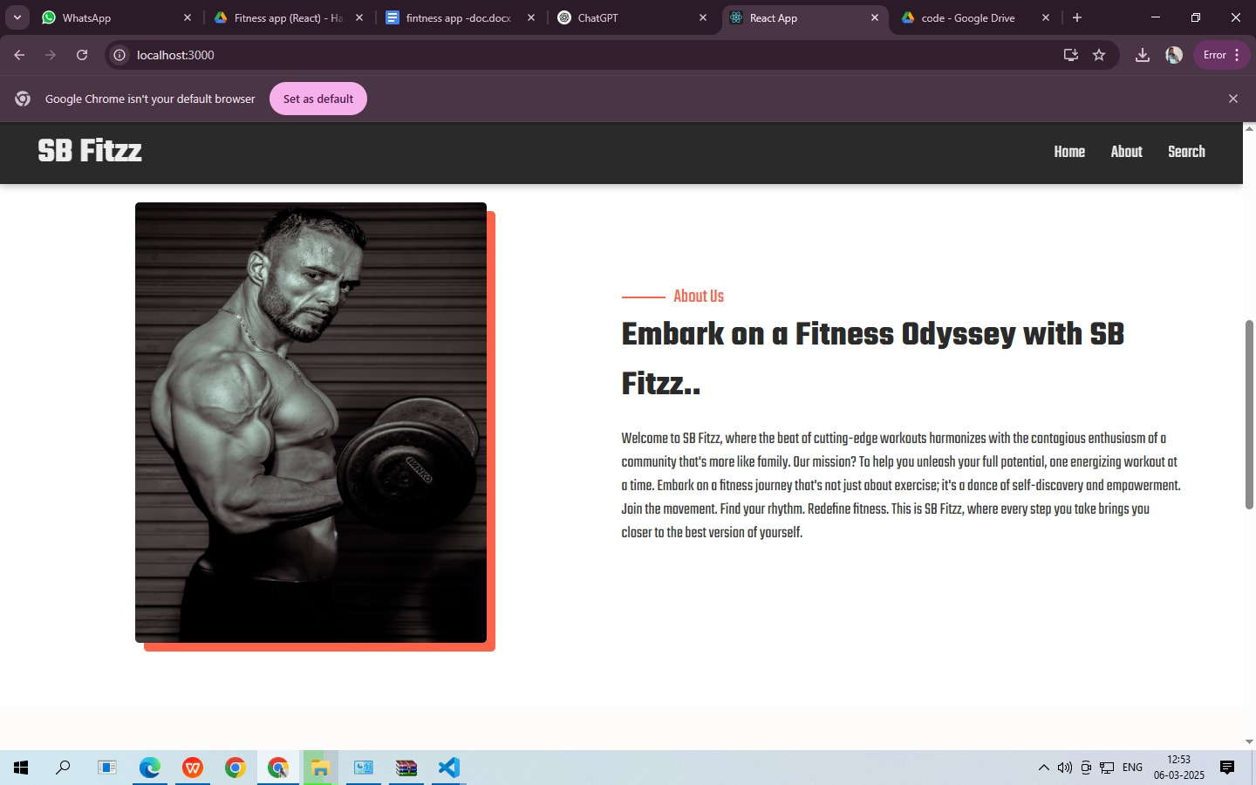

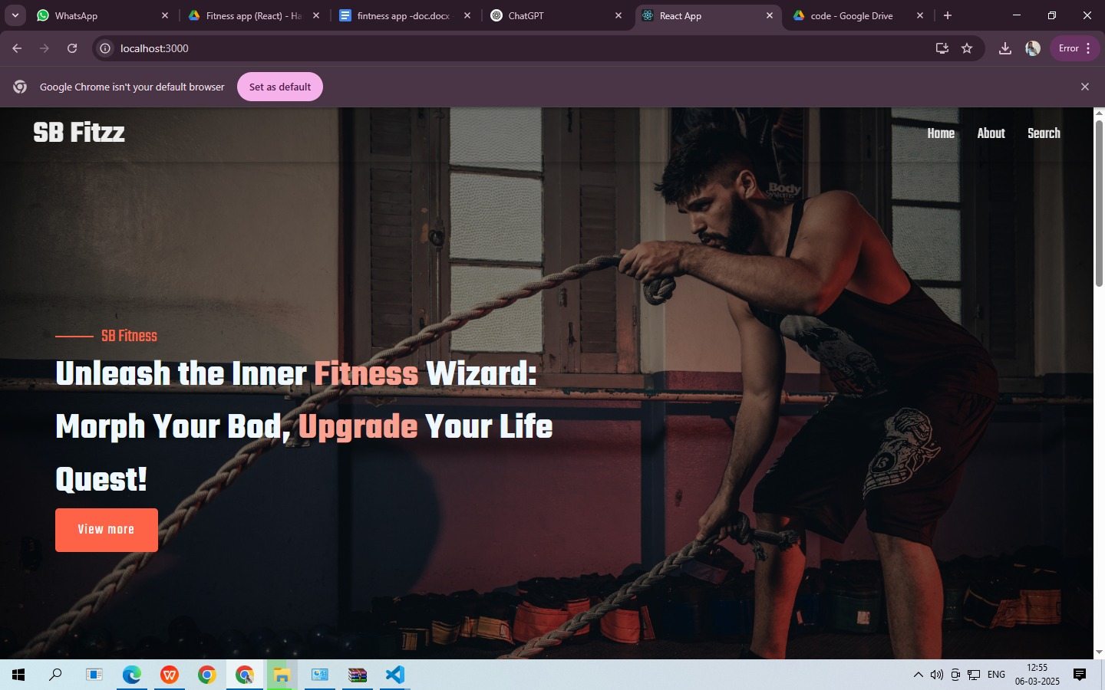

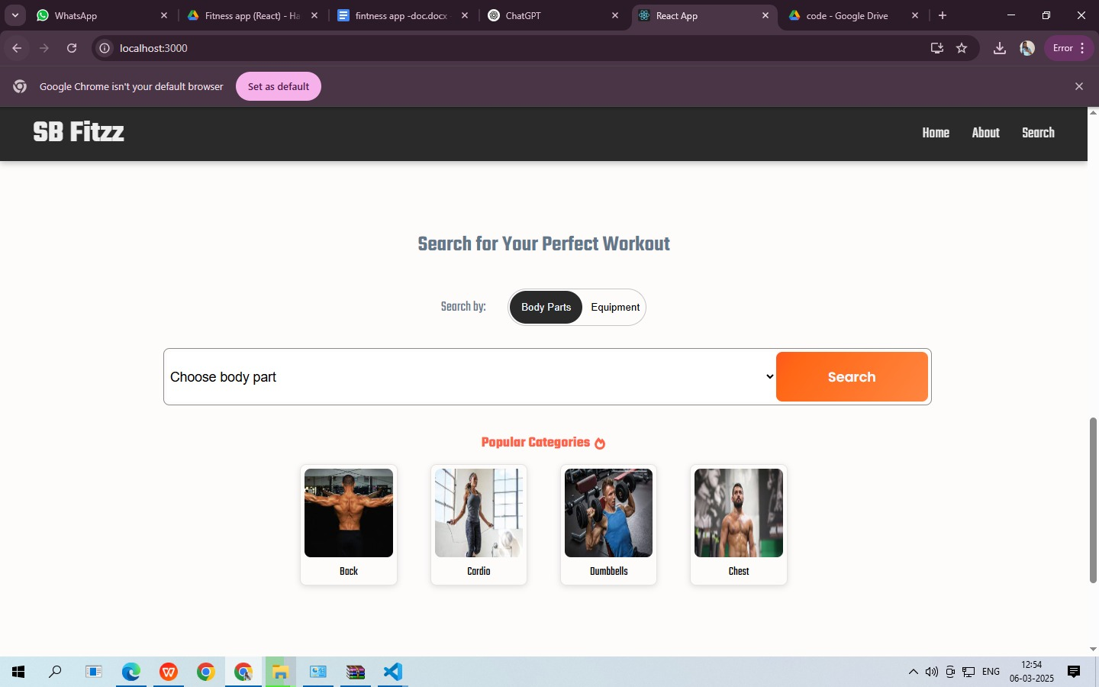

Tables

|  |  |
| --- | --- |
| **User Data Table**: | Stores user profiles, preferences, and progress. |
| **Exercise Table**: | List of available exercises categorized by goal and difficulty. |

Codings

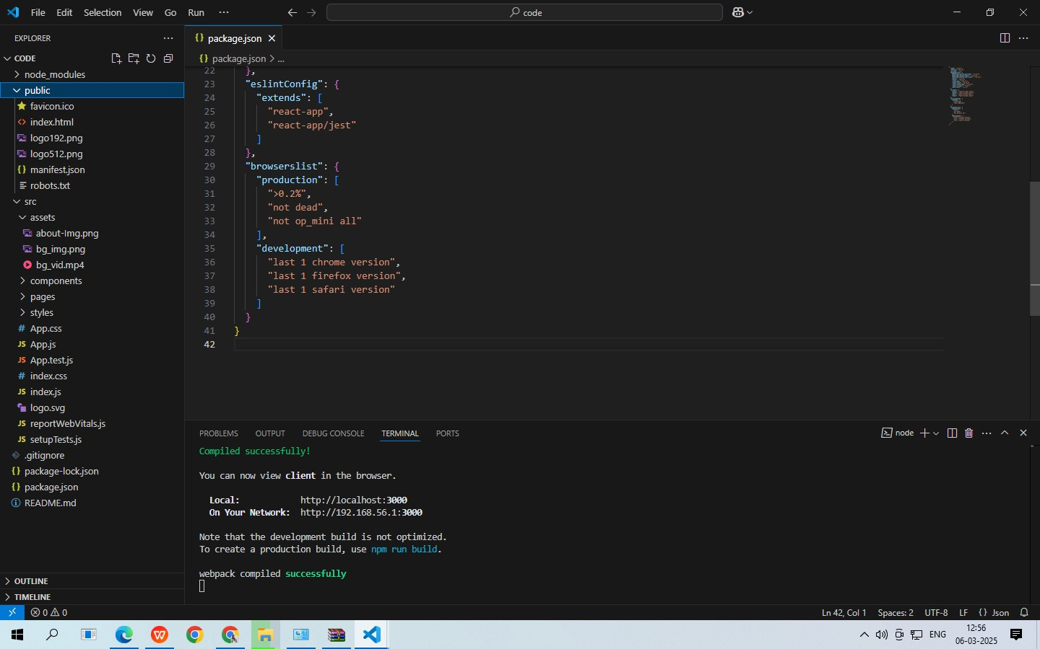

Reports

A detailed report of the system’s functionality, testing phases, and performance metrics will be included in the full documentation.

**Bibliography**

1. React.js Documentation: https://reactjs.org/docs/getting-started.html
2. Firebase Documentation: https://firebase.google.com/docs
3. Material-UI Documentation: https://mui.com/getting-started/installation/
4. Chart.js Documentation: https://www.chartjs.org/docs/latest/
5. Fitbit API Documentation: https://dev.fitbit.com/build/reference/web-api/